# Basic Electronic Transistors

Written by Mark Webster

***Summary***

In this workshop learn to make a simple transistor switch or amplifier to use with other electronic projects such as Arduinos.

## Introduction

Transistors are like valves in a water pipe. A small rotation of the valve causes a large difference in the amount of water flowing through the pipe. If the valve is turned full open or full closed, then it works like a switch. If the valve is left partially open, small movements of the valve make large differences in the water flow in the pipe so they amplify the changes in the valve position. Similarly, transistors control the flow of current in a wire. The transistor can work as a switch (full on or full off). The transistor can also work as an amplifier making large changes in the flow of current in a wire with small changes in the input.

Transistors are semiconductor devices usually made from silicon or germanium, although gallium arsenide or organic transistors exist.

The type of transistor discussed here is called a bipolar junction transistor (BJT), although field effect transistors (FET) and MOSFET are also common. Less common transistors like tunnel field-effect or unijunction won’t be covered.

<https://en.wikipedia.org/wiki/Transistor>



Transistor packages in order from right to left: TO-3, TO-126, TO-92, SOT-23.

TO-92 is the most common in microelectronics, although TO-220 is common for high power transistors. The larger packages carry more current and have better heat dissipation.

Transistors are used in two main ways: as **switches**, and as **amplifiers**. Transistors are smaller, faster, and use less power than their alternatives like electromechanical relays or vacuum tubes.

Transistors have three pins, unlike diodes which have only two. The third pin is for the Gate/Base. When the voltage at the Base alternates between Vcc and ground, the transistor is a switch. If the voltage at the base is part-way between Vcc and ground, the transistor is an amplifier.

## NPN and PNP

A bipolar junction transistor can be thought of as two diodes connected together.

A diode limits current flow to one direction, thought of as from anode to cathode.

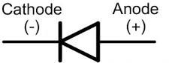(replace image)

The two types of BJT transistors are called NPN and PNP. Notice for the NPN transistor, current will flow from Base to Emitter only when the base is more positive than the emitter. In the PNP transistor, current will flow when the Base is lower voltage than the emitter.

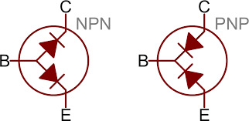(image from Sparkfun. Replace)

The schematic symbols look similar to the diode diagram, with the arrow indicating current flow direction relative to the base.

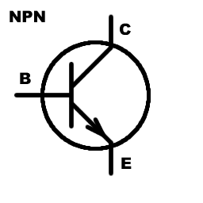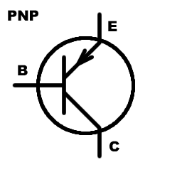

The original uploader of this image was DaRy at Swedish Wikipedia. - Transferred from sv.wikipedia to Commons., CC BY-SA 3.0, <https://commons.wikimedia.org/w/index.php?curid=1395673>

A memory trick is NPN stands for “Not Pointing IN”, since the arrow for NPN points from the inside of the transistor toward the outside. The arrow in the schematic symbol connects the base to emitter.

The B stands for “Base”, the E stands for “Emitter”, and the C stands for “Collector”.

The diode (arrow) connecting the base to the emitter indicates which way the current flows. With NPN the transistor is “on” when the base is more positive than the emitter. The PNP is “on” when the base is less positive than the emitter.

When a transistor is used as a switch, the base is put to Vcc or ground level. When used as an amplifier, the base is held part-way between Vcc and ground.

NPN transistors have electron flow, PNP have flow of holes. NPN are slightly faster.

With NPN circuits usually the load is between the collector and Vcc. With PNP circuits usually the load is between the collector and ground.

BJT (bi-junction transistors) have different casing types. Here are the two common ones (TO-92 and TO-220) for NPN transistors:

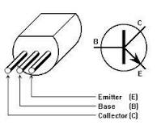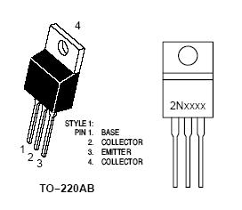NPN pinouts (replace image)

For PNP the base is also the middle pin for the TO-92 case but emitter and collector pins are switched.

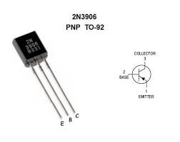(replace images)

## FET Transistor

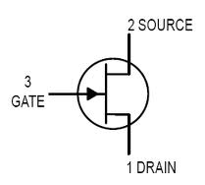(replace images)

FET (field effect transistor) and MOSFET (metal oxide semiconductor field effect transistor) have three pins labeled Gate, Source and Drain. The Gate functions like the Base on bi-junction transistors. MOSFET can be N or P type, similar to the NPN and PNP bi-junction transistors.

BJT transistors are usually preferred for lower current applications, and MOSFET are usually preferred for high current applications. MOSFET transistors switch faster than BJT.

MOSFETs come in different cases like TO-220 and TO-92. Here are two common cases and the pinouts:

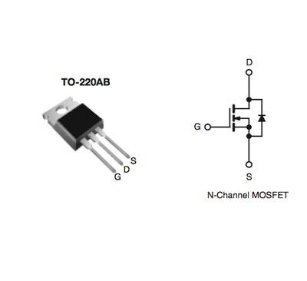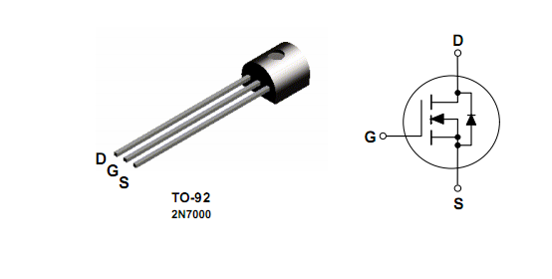(replace images)

## Testing a Transistor

To test whether a transistor is working, many multimeters have a simple function. There are 4 holes: EBCE. Place the transistor in the holes where Base, Emitter, and Collector pins line up with the type of transistor. This will be different for NPN and PNP. Also different for TO-92 and TO-220 packages. Be sure to press the transistor pins all the way into the hole.

Turn the selector to NPN or PNP. The reading will be the approximate gain of the transistor. The meter runs a small current into the base and reads the current flow through the Emitter-Collector. The ratio is the gain. If the transistor is working the amount of HFE (gain) should be high, often in the hundreds.

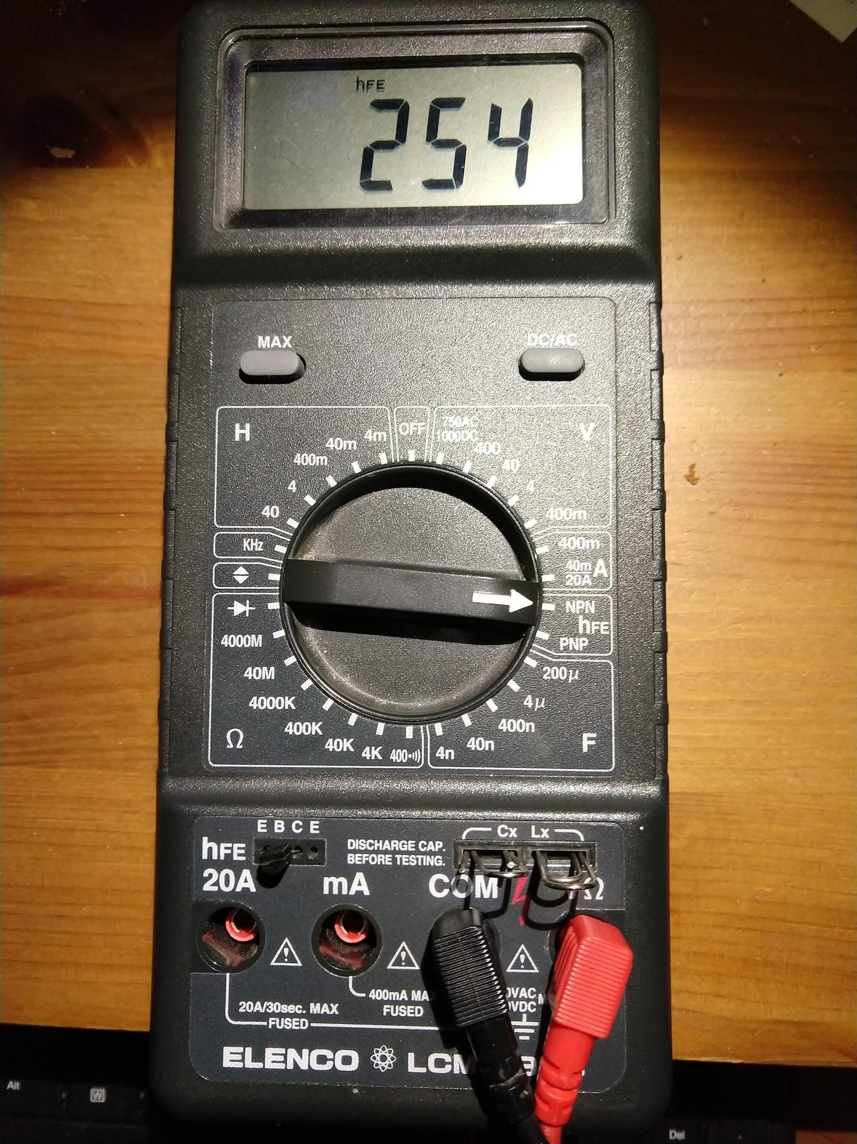

## Transistor Switches

A microcontroller like an Arduino sends small amounts of current from it’s pins, usually less than 40 mA. Devices like motors, solenoids, pumps, LED strips take much larger amounts of current. A transistor (or electromagnetic relay) works as an electronic switch so the low power Arduino can drive a high power device.

### NPN (5V at base is ON, 0V is off)

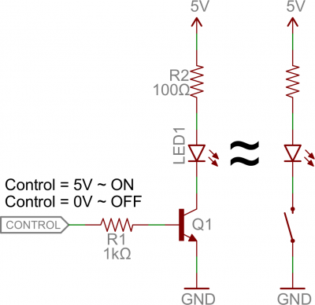 (Image from Sparkfun. Replace)

The resistor R1 on the transistor Base is to limit the current into the transistor. If using a pushbutton, the transistor can burn up if there is no limiting resistor. Arduinos internally limit the current coming out of a pin, so the current limiting resistor R1 is less necessary. The resistor R2 on the collector is to limit the current through the LED.

### PNP (with a 12V Vcc, about 12V at Base is OFF, 0V is on)

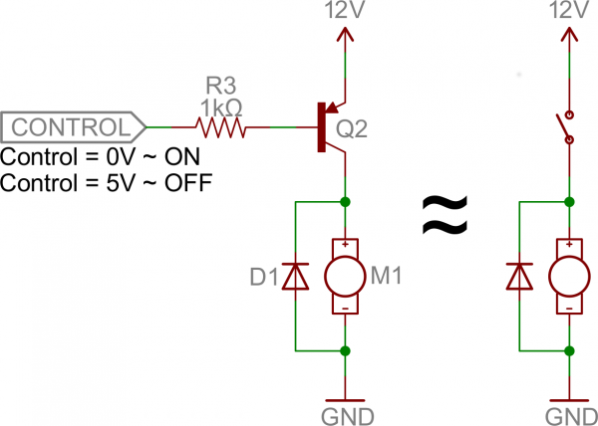 (Image from Sparkfun. Replace)

Notice the NPN is ***on*** when the base voltage is high, the PNP is ***on*** when voltage is low. Again, the resistor R3 limits the current flow when the base is emitter is biased off at Vcc.

### MOSFET

Here is an example of an Arduino used to control a 5 meter long LED strip using a MOSFET

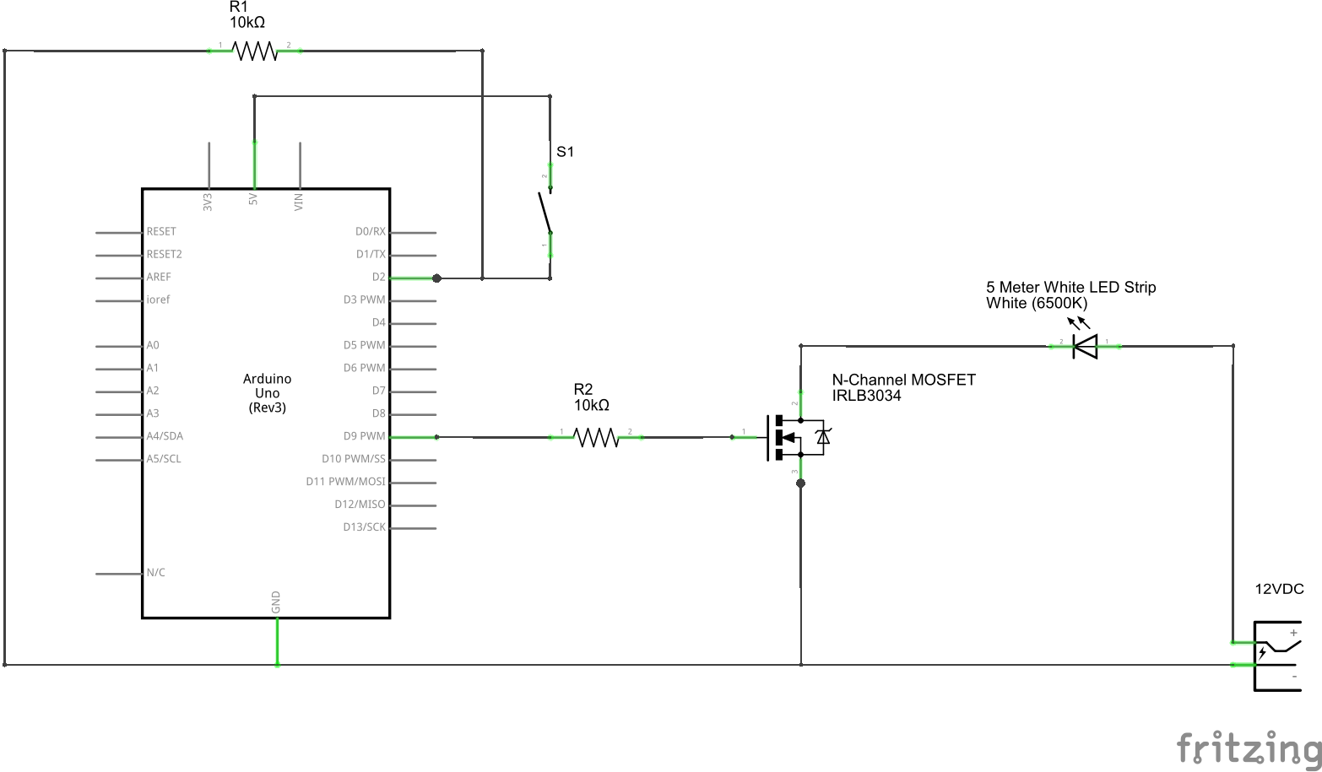

(From arduino-stack-exchange. Replace)

MOSFETs come in N-Channel and P-Channel types. Place the load on the drain side, which is reversed for N and P channel types.

N-Channel Typical circuit P-Channel Typical circuit

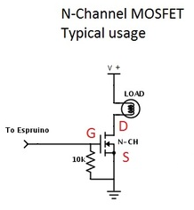 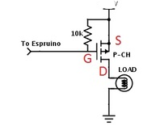(replace image)

## Audio Amplifier

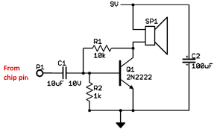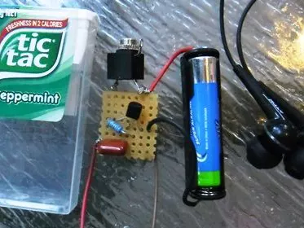(replace)

<https://www.hackster.io/jwzumwalt/single-transistor-audio-amp-32033a>

Transistors can be an amplifier if the base is held at part-way between ground and Vcc. This is done with a voltage divider R1 and R2. Since the input signal is at a different DC level, a blocking capacitor C1 is used to prevent a conflict between the DC voltages at the base of the transistor and the signal input.

The small voltage/current at the transistor base controls a much larger voltage/current between the collector and emitter. A capacitor is used on the input to isolate DC levels and only let the AC audio signal through. Often a blocking capacitor is used on the output to run the speaker at a different voltage than the transistor. The capacitor can also be used as a temporary power source for voltage spikes.

## Exercises

### Exercise 1:

Use a push-button turns on an LED with an NPN transistor by raising the Base voltage to almost Vcc. Thus the transistor works as a switch, going from 0V to Vcc. Remember to put a current limiting resistor on the LED. If you use an Arduino instead, use a 5V power supply since the Arduino can only raise it’s output pin voltage to 5V.

In this photo a 9V battery was used instead of 5V from an Arduino, so a resistor divider was used on the button to base pin. 100 ohm to 10K ohm is the ratio, with 10K connecting the base to to ground. This 10K acts as a pull down resistor. The 100 ohm resistor limits the current flowing between base and collector so the transistor doesn’t burn up. When the button is pressed, the voltage at the base will be 99% of Vcc which turns the transistor completely on.

When the button is open (off) the voltage on the base is pulled down to ground (0V). When the button is closed (on) the voltage is raised to almost Vcc. When the transistor is on, the 100 ohm resistor limits current flow through the base-collector.

The circuit here is the typical Common Emitter configuration since the Emitter of the transistor is connected to ground. The LED in an NPN circuit is usually between Vcc and the transistor.

In this photo a BC337 NPN transistor is used although the 2N222 transistor is almost equivalent.

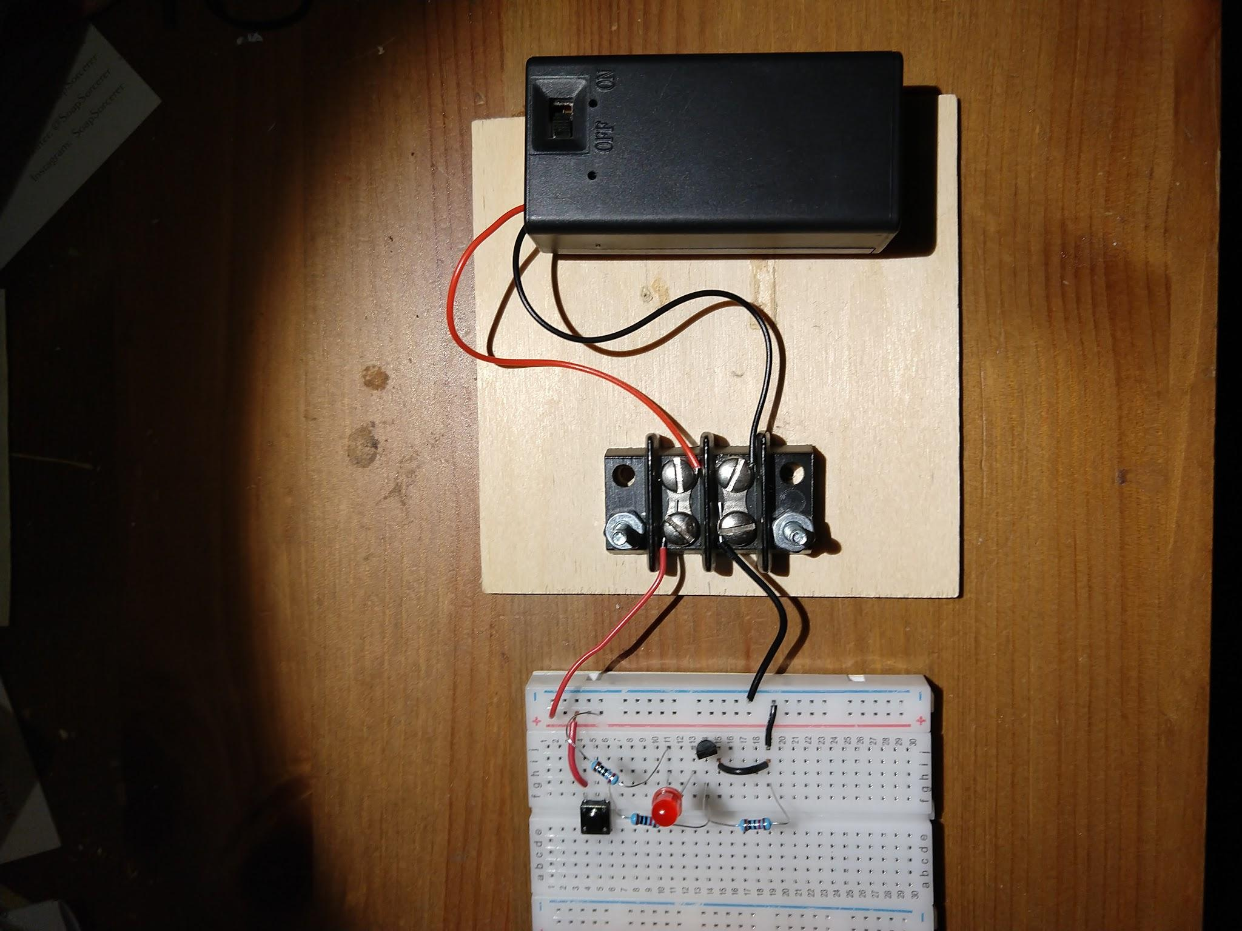

### Exercise 2:

Use a pushbutton to turn on an LED with a PNP transistor. Recall, the PNP is off when the base is held to Vcc, and on when the base is brought to ground. In this case, the current limiting pull up resistor is between Vcc and the base, so the transistor doesn’t burn up. No current limiting resistor is needed when the button is closed and pulls the base to ground, since no current will flow between 0V and 0V.

The PNP transistor circuit is very similar to the NPN. The change is the button will pull the base pin voltage low instead of high. A 10K ohm pull-up resistor is used to hold the base at the Vcc (9V) maximum to keep the transistor turned off. The LED is between the transistor and ground instead of Vcc and the transistor. A BC327 PNP transistor was used.

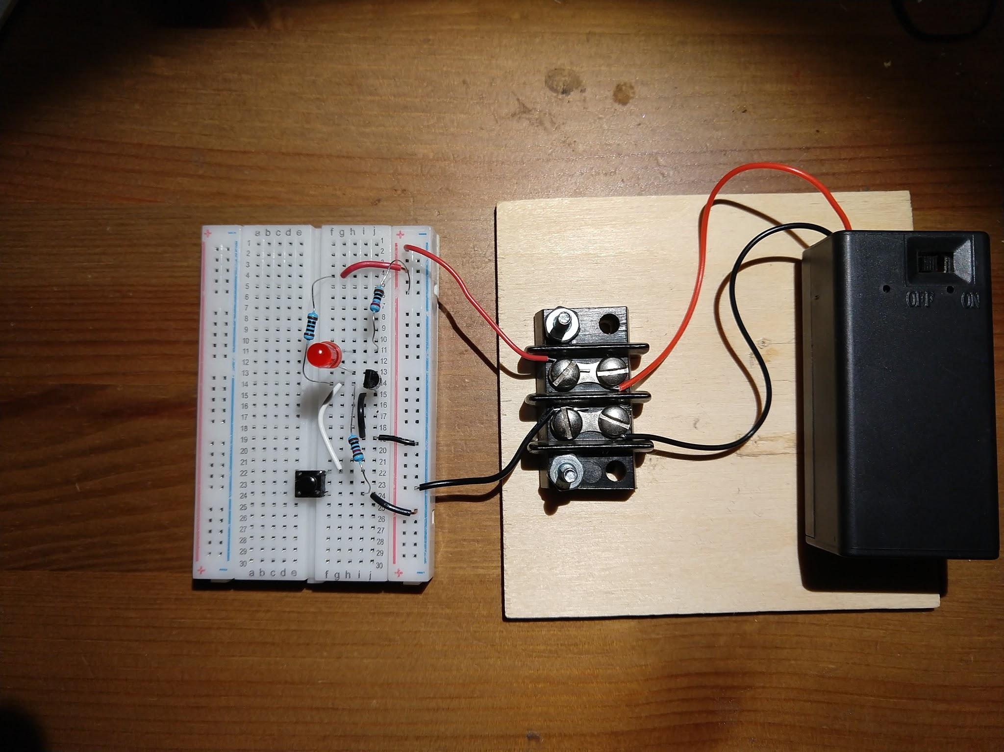

### 

### Exercise 3:

Use a pushbutton to turn on an LED with a N-Channel MOSFET. The circuit is almost the same as the NPN transistor in exercise 1.

The Vout is connected to the LED + Resistor.

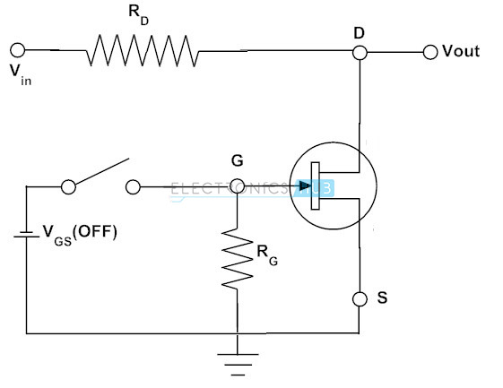(replace)

### Exercise 4:

Make an NPN audio amplifier and demonstrate that a sine wave input from a function generator is amplified. The voltage at the base of the transistor is held part-way between ground and Vcc instead of at ground like in the switch. The resistor ratio determines the gain of the transistor. Any ratio that gives a gain over 2 is useful to demonstrate the circuit.

A capacitor blocks DC into the base since the voltages at the transistor and the signal source are different..

A potentiometer volume control resistor divider will be needed on the transistor amplifier input. Optionally connect the output to a small powered speaker or earbuds. If no speaker is available then replace with a 100 ohm resistor. Look at the output signal amplitude with an oscilloscope and notice it is larger than the input. The capacitor on the output is a filter and a temporary power source.



The photo seems complicated but the only part constructed is on the small breadboard. The function generator is on the top left, and the oscilloscope on the bottom left is to view the output. On the right is a 9V battery to power the circuit. As a bonus, the output is connected to a small powered speaker. If no speaker is available, just use a fixed resistor.

